Name:
Jotunheimen Super Randonnée
Route:
http://www.openrunner.com/index.php?id=3136206
Elevation on OpenRunner : 10736 m
Cue Sheet (Road book):
Red segments are gravel roads or have stretches of gravel road.
Distance | Diff |  | Control/Photo object | Turn | Road/direction
0 km | 0 km | Gudvangen | Gudvangen fjordtell |  | Southwest
1 km | 1 km |  |  | →
10 km | 9 km |  |  | ← | 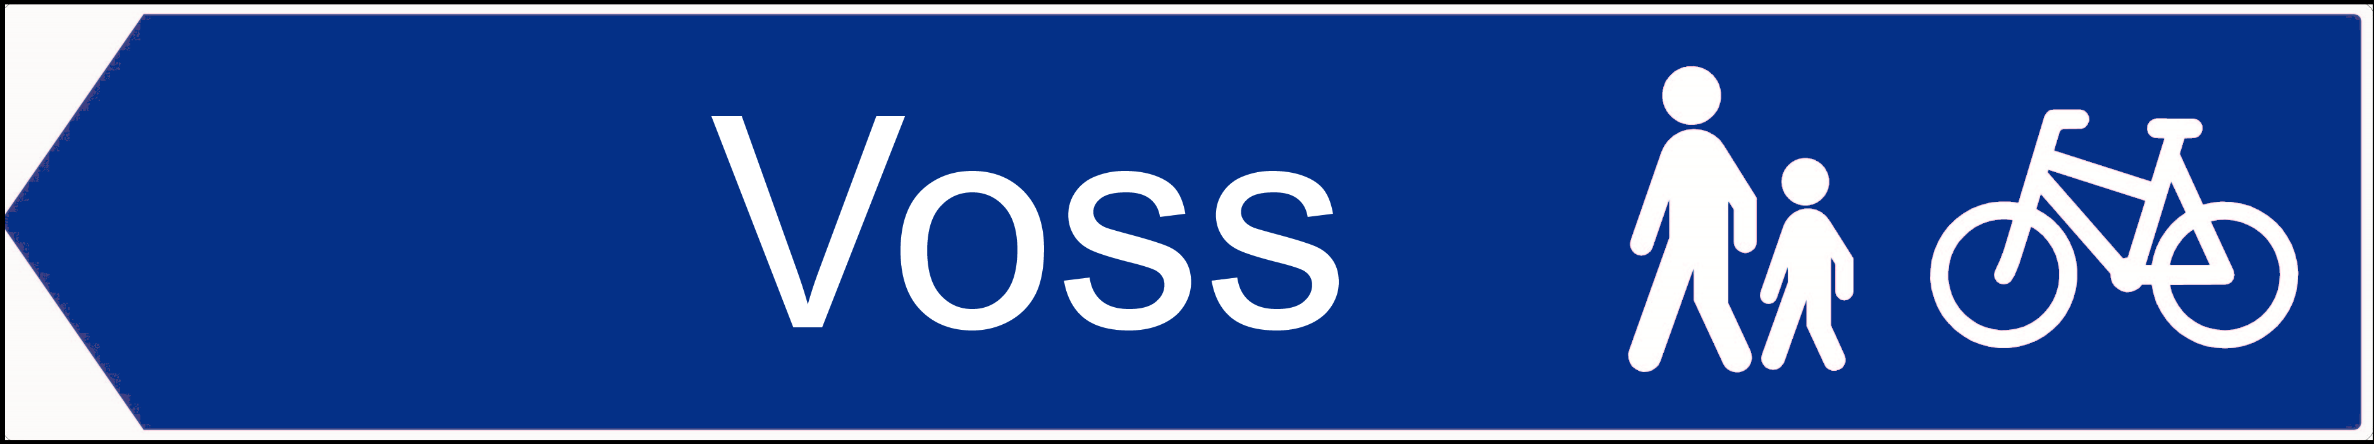
12 km | 2 km | Stalheim hotell | Stalheim hotell | ↑
14 km | 2 km |  |  | →
26 km | 12 km | Vinje |  | Roundabout, first exit | 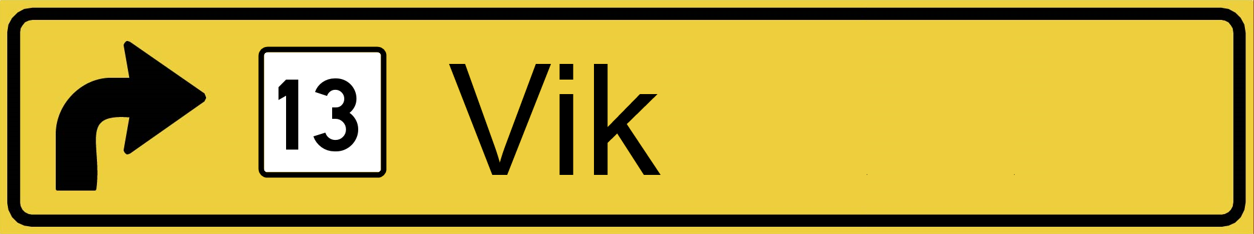
83 km | 57 km | Vangsnes | Ferry | ↑ | Hella
83 km | 0 km | Hella |  | ↑
119 km | 36 km | Sogndal |  | Roundabout, first exit
121 km | 2 km |  |  | ←  Before bridge
149 km | 28 km | Gaupne | Glass pyramid shopping centre | ↑ | 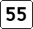
206 km | 57 km | Sognefjellet | Sign «1434 m.o.h.» at car park | ↑
236 km | 30 km | Bøverdal camping |  | → | 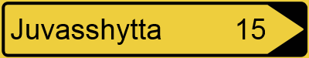
250 km | 14 km | Juvasshytta | Sign «Galdhøpiggen sommerskisenter» | ↓
264 km | 14 km | Bøverdal camping |  | →
283 km | 19 km | Lom |  | Roundabout, first exit | 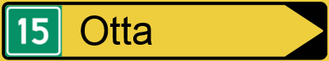
307 km | 24 km |  |  | →
323 km | 16 km | Lemonsjøen |  | ↑ | 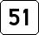
373 km | 40 km | Valdresflya | Sign «Valdresflya 1389 m.o.h.» | ↑
400 km | 27 km |  |  | →
415 km | 15 km |  |  | →
419 km | 4 km | Høre | Church Høre stavkyrkje | ↑
427 km | 8 km | Dale |  | → | 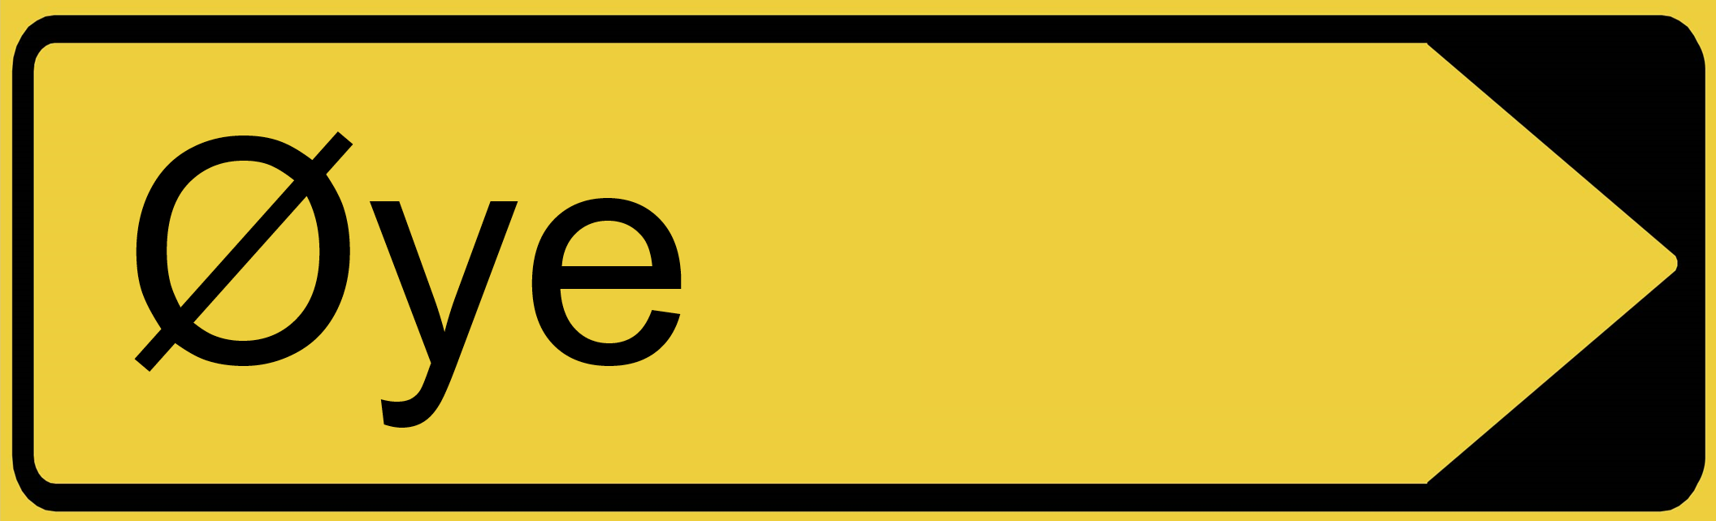
446 km | 21 km | Nedre Dalen |  | →
485 km | 39 km |  |  | →
487 km | 2 km | Borgund | Church Borgund stavkyrkje | ↑
492 km | 5 km |  |  | →
495 km | 3 km |  |  | → | 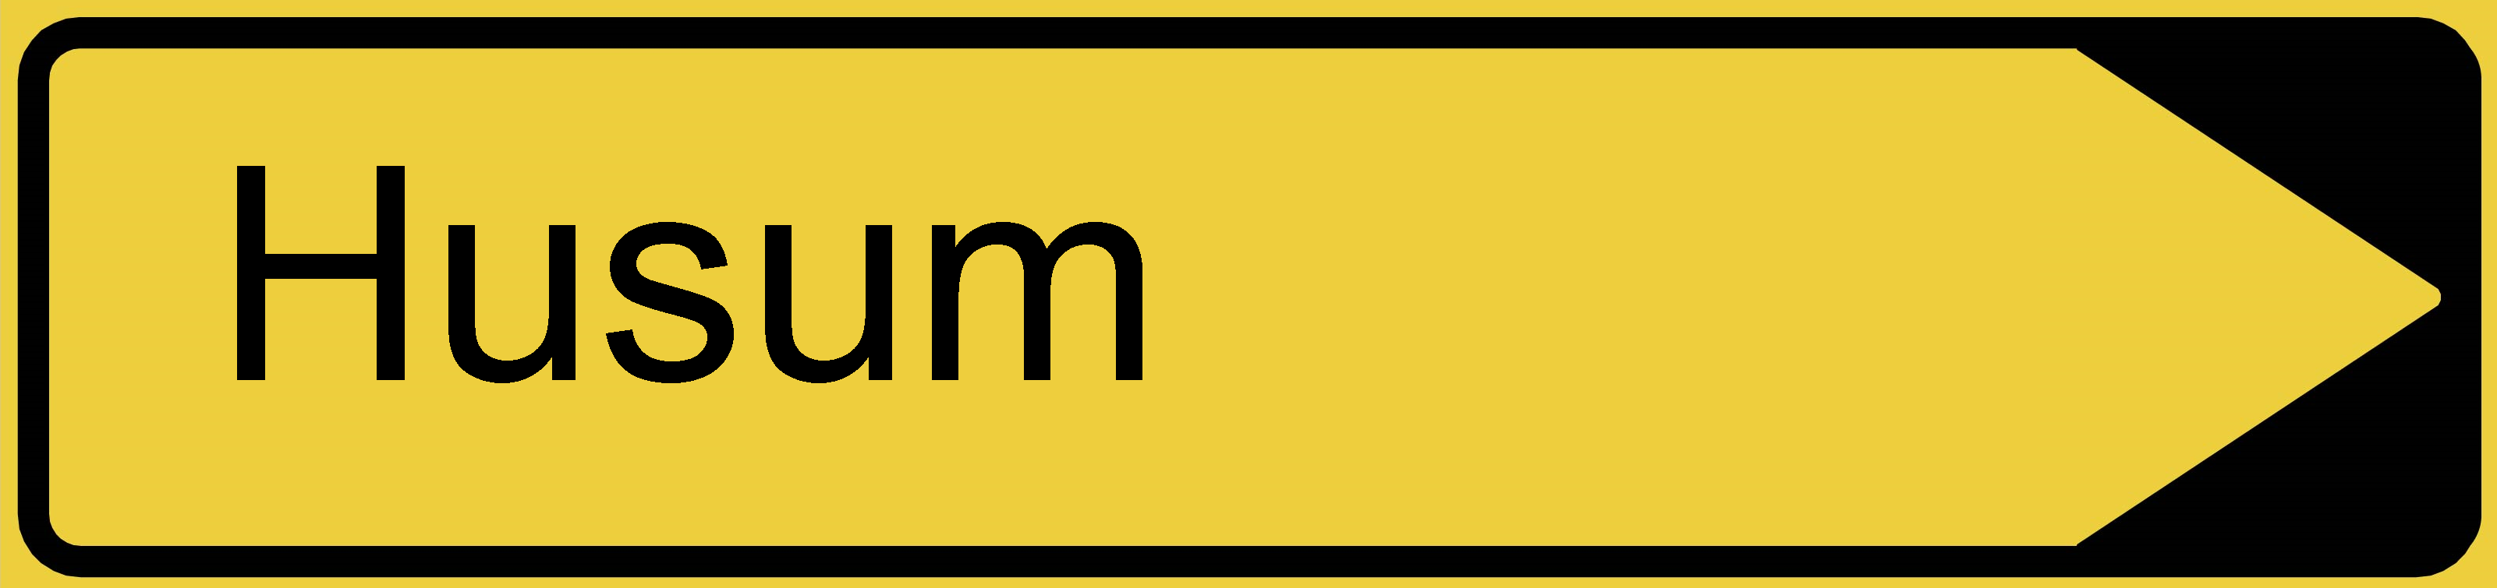
507 km | 12 km |  |  | →
520 km | 13 km |  |  | Roundabout, first exit | 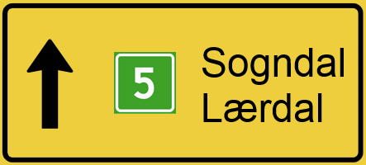
527 km | 7 km | Lærdalsøyri | Esso station/bus terminal | ↑
527 km | 200 m |  |  | Roundabout, second exit | 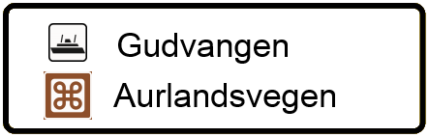  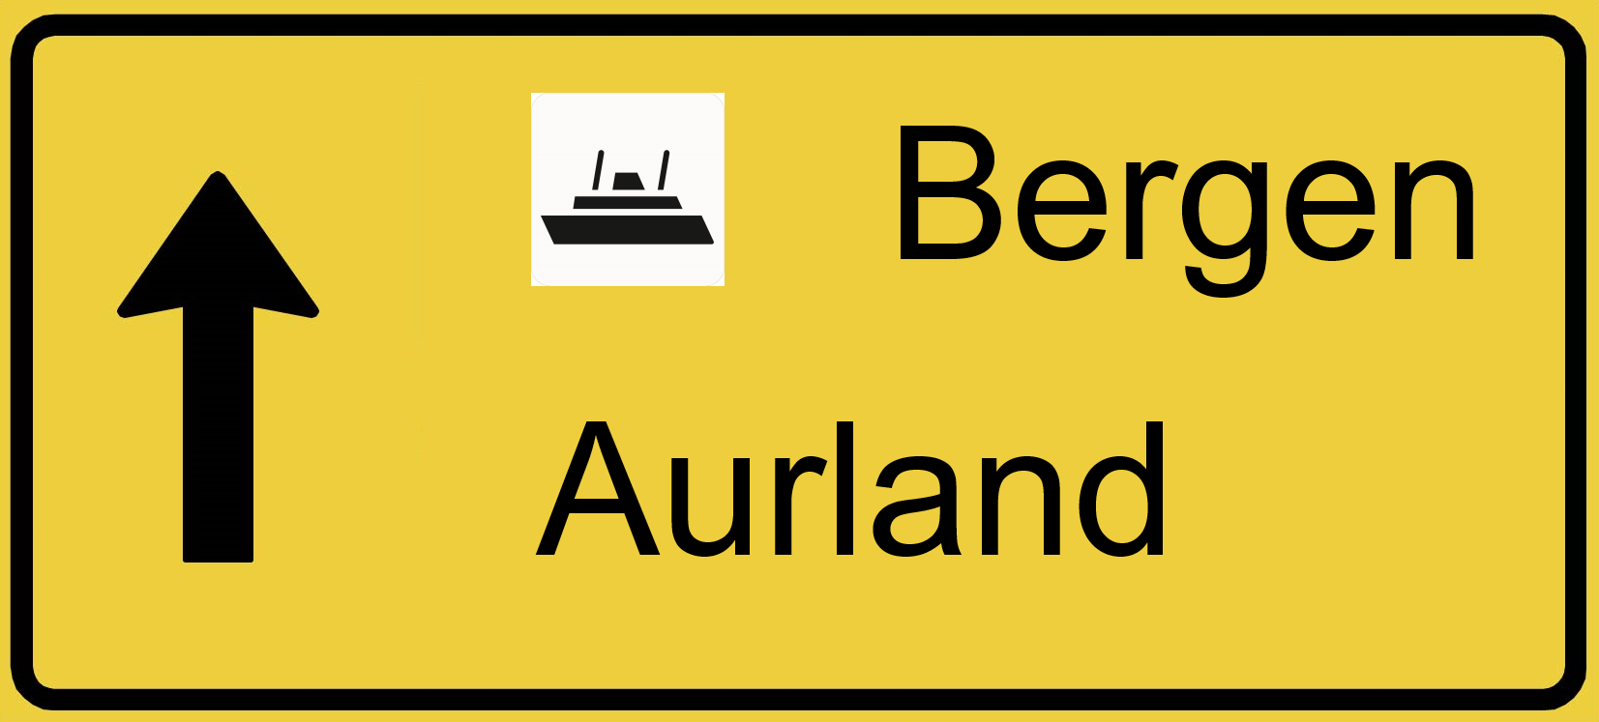
530 km | 3 km |  |  | ← | Aurlandsvegen
574 km | 44 km | Aurland |  | ↑ | 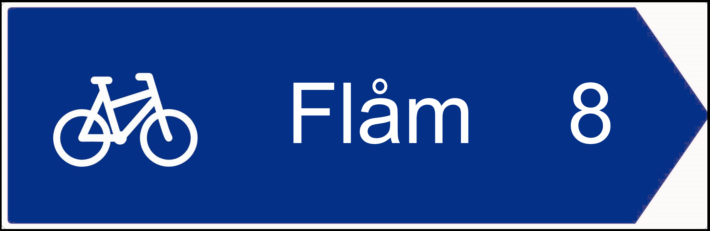
576 km | 2 km |  |  | → | 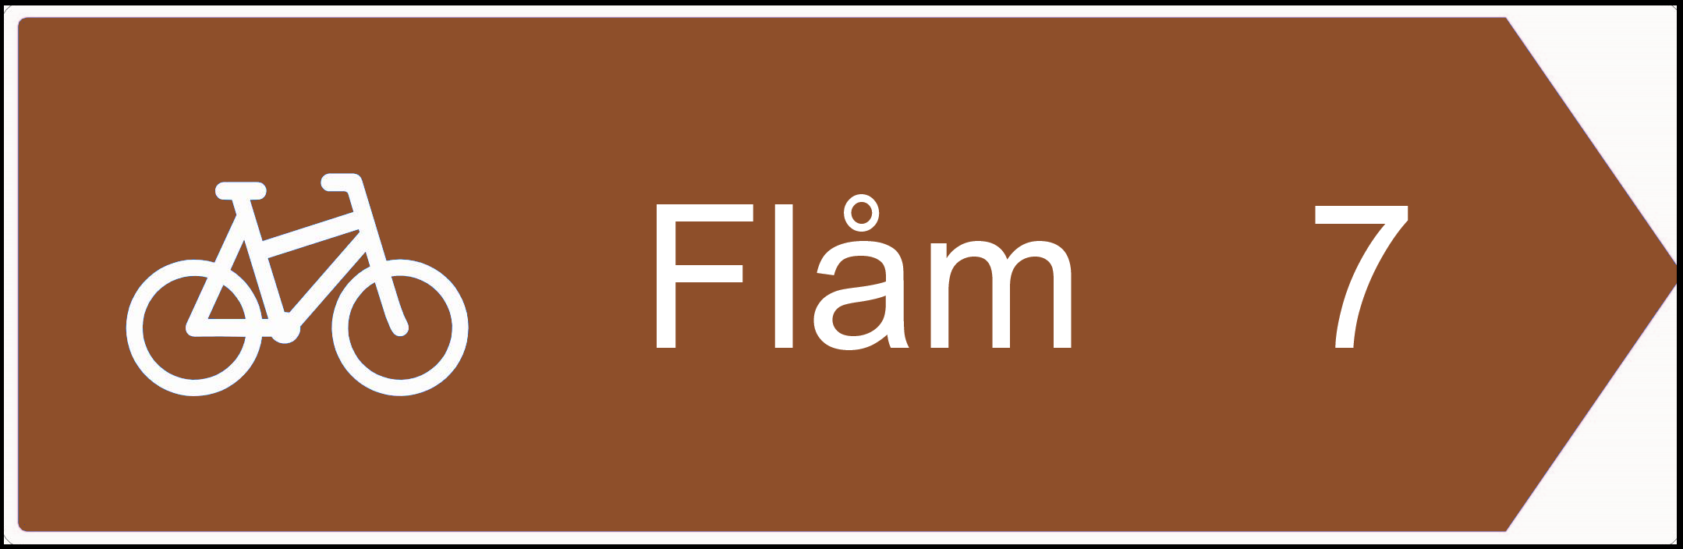
578 km | 2 km |  |  | → | Parallel bike path
581 km | 3 km | Flåm |  | ↑ | Bike path becomes road, Vikjavegen
582 km | 1 km |  | Flåm railway station | → | Enter harbour/ railway station
582 km | 100 m |  |  | ↓ | Leave railway station same way you entered
582 km | 50 m |  |  | →
582 km | 100 m |  |  | ↑ | Follow parallel rail tracks
594 km | 12 km | End of paved road
600 km | 6 km | End of gravel road – end of course. Stop here and do not continue beyond this point. | Sign «Rallarvegen» prohibited for motor vehicles
602 km | 2 km | Vatnahalsen stasjon

